**Introduction to DevOps and Continuous Integration**

**What is DevOps?**

* DevOps is a set of practices that combines software development (Dev) and IT operations (Ops). The goal is to shorten the development lifecycle and deliver high-quality software continuously.
* Key Idea: Breaking down silos between development and operations teams to work together more efficiently.

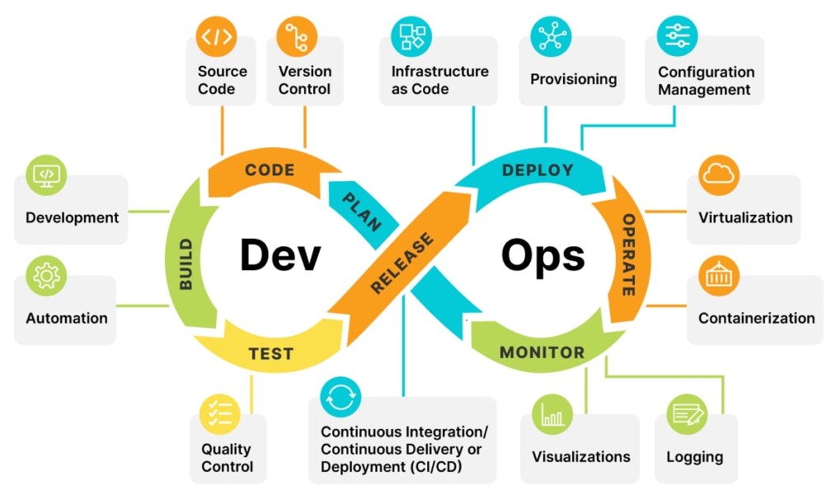

**Need for DevOps Culture**

* Faster Delivery: Accelerates the time from development to production, ensuring quicker releases and updates.
* Improved Collaboration: Encourages communication and collaboration between developers, testers, and operations.
* Better Quality: Continuous testing and monitoring lead to higher-quality software.
* Scalability: Easily scalable infrastructure and processes to meet changing demands.

**Continuous Integration (CI) / Continuous Delivery (CD)**

* Continuous Integration (CI): A practice where developers frequently merge their code changes into a shared repository, followed by automated builds and tests. This helps catch issues early.

Each time a developer commits code, automated tests run to ensure the new code doesn’t break existing functionality.

* Continuous Delivery (CD): Extends CI by automatically deploying all code changes to a testing or production environment after the build stage. Ensures that the software can be released at any time.

After passing automated tests, the new code is automatically deployed to a staging environment for further testing.

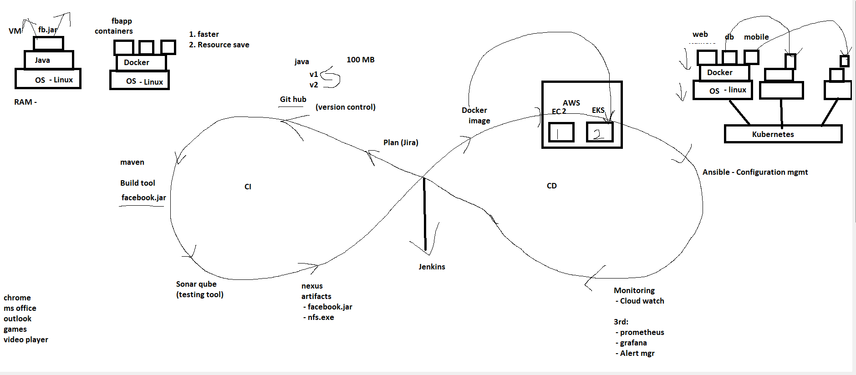

**Benefits of DevOps**

* **Speed**: Increases the speed of delivering applications and updates.
* **Reliability**: Ensures the quality of application updates and infrastructure changes, allowing for reliable delivery at a more rapid pace.
* **Scale**: Helps manage complex or changing systems efficiently with reduced risk.
* **Security**: Integrates security practices into the DevOps workflow, ensuring secure and compliant releases.
* **Innovation**: Frees up more time for innovation and improvement, rather than spending it on manual processes and fixing issues.